Experiment 14
Program:
import cv2
import numpy as np
# Read the input image
img = cv2.imread("image.jpg")
# Get image size
rows, cols, ch = img.shape
# Define 4 points in the original image
pts1 = np.float32([[50,50], [200,50], [50,200], [200,200]])
# Define corresponding points in the transformed image
pts2 = np.float32([[10,100], [200,50], [100,250], [220,220]])
# Compute perspective transformation matrix
matrix = cv2.getPerspectiveTransform(pts1, pts2)
# Apply perspective transformation
result = cv2.warpPerspective(img, matrix, (cols, rows))
# Display images
cv2.imshow("Original Image", img)
cv2.imshow("Perspective Transformed Image", result)
cv2.waitKey(0)
cv2.destroyAllWindows()
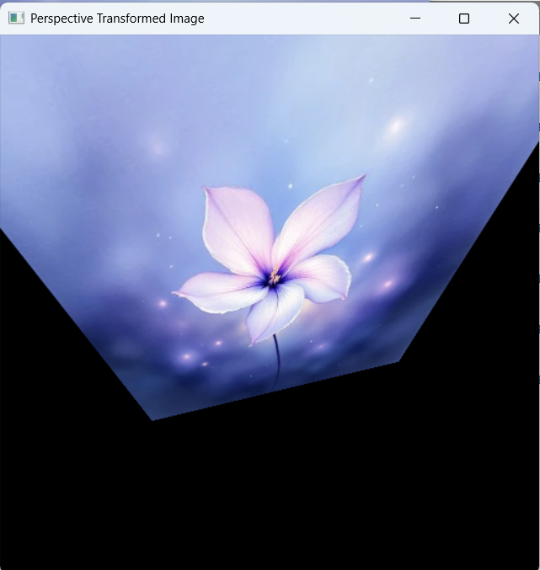
Output

